
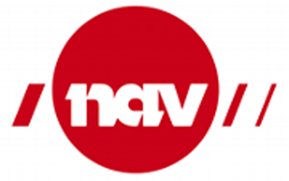
EURES – Vacancy form
Employer
Registration number
Employer | Valsøya Fjordcamping AS
Contact person | Liv Bjerknes
Telephone number | 41265545
Fax number
Address | Valsøyvegen 1, 6687 Valsøyfjord, Norway
E-mail | liv@valsoya.no
Website | www.valsoya.no
Principal employer (if vacancy is handled through recruiting or staffing company)
 | Show principal employer in ad? Yes __ No _X_

Description of Company
Number of vacant positions: 2

Job title | Chef
Job description | - Daily participation in kitchen operations  - Production, mise en place and service  - Perform washing and cleaning of kitchen facilities in accordance with internal control at the kitchen (IK-Mat) and HACCP  - Contribute input to menu planning and concept development especially in concern of using local produce.  - Positive contribution to community and communication with colleagues and guests
Skills:  Education, work experience, language, certificate etc. | - Certificate as a chef  - Long experience within the industry, and good references can compensate for the lack of certificate as a chef  - Being able to communicate in English is a requirement  - It is an advantage if you also can manage one of the Scandinavian languages
Working hours and place of work | The work is whift-based an working hours will vary from day to day, place of work is Valsøya.
Type of contract (permanent or temporary, if temp state length) | Temporary contract from May to October 2022.
Start date (and if necessary, End date) | 15th of May – 16th of october
Salary | Salary according to tariff
Other information

Application
Last application day | 30th of april
How to apply? | Apply by sending CV and a presentation of yourself in an email
Contact person/ telephone number | Liv Bjerknes (Restaurant Manager), Tlf: +4741265545
E-mail | liv@valsoya.no
Other information | Applications are processed continously

